****Name: Nikesh Dahal

CRN: 074-BCt-043

Subject: DSAP

**LAB 01: Introduction to different types of basic signals**

**Objectives:**

1. To introduce about different types of basic signals**.**

**Software used:**

MATLAB: MATLAB is a high-performance language for technical computing, it integrates computation, visualization, and programming in an easy to use environment where problems and solutions are expressed in familiar mathematical notation.

**Theory:**

A signal may be a function of time, temperature, position, pressure, distance, etc. A signal is generally given in time domain. Time domain specifies that what the amplitude of the signal is at a particular time instant. Some signals in our daily life are music, speech, picture and video signals. A signal can be systematically defined as “A function of one or more independent variables which contains some information”. In electrical sense, the signal can be voltage or current. The voltage or current is the function of time as an independent variables. In daily life, we come across several electrical such as radio signal, T.V signal etc.

Types of signal:

* Continuous Time and Discrete Time Signals.
* Deterministic and Non-deterministic Signals.
* Even and Odd Signals.
* Periodic and Aperiodic Signals.
* Energy and Power Signals.
* Real and Imaginary Signals.

If the signal amplitude is defined for every possible value of time, the signal is called a continuous-time signal. However, if the signal takes values at specific instances of time but not anywhere else, it is called a discrete-time signal. Basically, a discrete-time signal is just a sequence of numbers.

**Unit step signal**

Unit step function is denoted by u(t). It is defined as u(t) = {1 t⩾0, 0 t< 0}. It is used as best test signal. Area under unit step function is unity.

**Unit impulse signal:**

In discrete time the unit impulse is simply a sequence that is zero except at n = 0, where it is unity. In continuous time, it is somewhat badly behaved mathematically, being of infinite height and zero width but having a finite area. The unit step and unit impulse are closely related.

**Signum signal:**

In mathematics, the sign function or signum function is an odd mathematical function that extracts the sign of a real number.

**Ramp signal:**

The ramp function is a [unary](https://en.wikipedia.org/wiki/Unary_function) [real function](https://en.wikipedia.org/wiki/Real_function), whose [graph](https://en.wikipedia.org/wiki/Graph_of_a_function) is shaped like a [ramp](https://en.wikipedia.org/wiki/Ramp). It can be expressed by numerous [definitions](https://en.wikipedia.org/wiki/Ramp_function#Definitions), for example "0 for negative inputs, output equals input for nonnegative.  
Ramp signal is denoted by r(t), and it is defined as r(t) = {t⩾0, 0 t<0. ∫u(t)=∫1=t=r(t) u(t)=dr(t) dt. Area under unit ramp is unity.

**Real exponential function:**

As functions of a real variable, exponential functions are uniquely characterized by the fact that the growth rate of such a function (that is, its derivative) is directly proportional to the value of the function.

**Complex exponential functions:**

Complex exponentiation extends the notion of exponents to the complex plane. That is, we would like to consider functions of the form e z e^z ez where z = x + i y z = x + iy z=x+iy is a complex number.

1. **WAP in MATLAB to draw a neat labelled diagram of the following DT signals in a single figure window:**

Fig specs: time axis -15 to 15; amp. Axis:-2 to 2

**Code:**

1. **Unit step signal:**

%% unit step signal

t = -15:1:15;

y = zeros(1,length(t));

for i = 1:length(t)

if t(i)>=0

y(i) = 1;

else

y(i) = 0;

end

end

subplot(2,2,1)

stem(t,y)

grid on

xlabel('time')

ylabel('amplitude')

title('plot of unit step signal')

axis([-15,15,-2,2])

1. **Unit impulse signal:**

%%impulse signal

t = -15:1:15;

y = zeros(1,length(t));

for i = 1:length(t)

if t(i)==0

y(i) = 1;

else

y(i) = 0;

end

end

subplot(2,2,2)

stem(t,y)

grid on

xlabel('time')

ylabel('amplitude')

title('plot of unit impulse signal')

axis([-15,15,-2,2])

%%impulse signal

1. **Signum signal**

%%signum signal

t = -15:1:15;

y = zeros(1,length(t));

for i = 1:length(t)

if t(i)>0

y(i) = 1;

elseif t(i)==0

y(i) = 0;

else

y(i) = -1;

end

end

subplot(2,2,3)

stem(t,y)

grid on

xlabel('time')

ylabel('amplitude')

title('plot of unit impulse signal')

axis([-15,15,-2,2])

%%signum signal

1. **Ramp signal:**

%%ramp signal

t = -15:1:15;

y = zeros(1,length(t));

for i = 1:length(t)

if t(i)>0

y(i) = 4*t(i);

else

y(i) = -1;

end

end

subplot(2,2,4)

stem(t,y)

grid on

xlabel('time')

ylabel('amplitude')

title('plot of unit impulse signal')

axis([-15,15,0,60])

1. **Wap in MATLAB to draw a neat labelled diagram of real exponential function y=ce^at for the following cases: a)c=1,a=1 b) c=1,a=-1**

**a)c=1;a=1**

c=1;

a=1;

t=-5:0.1:5;

y=zeros(1,length(t));

y=c*exp(a*t)

subplot(2,1,1)

stem(t,y)

grid on

xlabel('time')

ylabel('amplitude')

title('plot of exponential function for a>0')

**b) c=1,a=-1**

c=1;

a=-1;

t=-5:0.1:5;

y=zeros(1,length(t));

y=c*exp(a*t)

subplot(2,1,2)

stem(t,y)

grid on

xlabel('time')

ylabel('amplitude')

title('plot of exponential function for a<0')

1. **Wap in MATLAB to draw a neat labelled diagram of complex exponential function y=ce^at for the following cases: a) c=1, a=0.5+1.5j , b) c=1,a=-0.5+1.5j c) c=1, a=15j**

Fig specs: time axis : -5 to 5 at increments 0.001

1. **c=1, a=0.5+1.5j :**

%% exponential function c=1,a= 0.5+15j

c = 1;

a = 0.5+15j;

t = -5:0.001:5;

y = c*exp(a*t);

y1 = real(y);

y2 = imag(y);

figure

subplot(2,2,1)

plot(t,y1)%%to plot DT

xlabel('time')

ylabel('amplitude')

title('real part of exponential function for real(a)>0')

grid on

subplot(2,2,2)

plot(t,y2)%%to plot DT

xlabel('time')

ylabel('amplitude')

title('imag part of exponential function for real(a)>0')

grid on

1. **c=1,a=-0.5+1.5j :**

%% exponential function c=1,a= -0.5 +15j

c = 1;

a = -0.5 +15j;

t = -5:0.001:5;

y = c*exp(a*t);

y1 = real(y);

y2 = imag(y);

subplot(2,2,3)

plot(t,y1)%%to plot DT

xlabel('time')

ylabel('amplitude')

title('real part of exponential function for real(a)<0')

grid on

subplot(2,2,4)

plot(t,y2)%%to plot DT

xlabel('time')

ylabel('amplitude')

title('imag part of exponential function for real(a)<0')

grid on

1. **c=1, a=15j :**

%% exponential function c=1,a= 15j

c = 1;

a = 15j;

t = -5:0.001:5;

y = c*exp(a*t);

y1 = real(y);

y2 = imag(y);

figure

subplot(2,1,1)

plot(t,y1)%%to plot DT

xlabel('time')

ylabel('amplitude')

title('real part of exponential function for imag(a)')

grid on

subplot(2,1,2)

plot(t,y2)%%to plot DT

xlabel('time')

ylabel('amplitude')

title('imag part of exponential function for imag(a)')

grid on

**Outputs :**

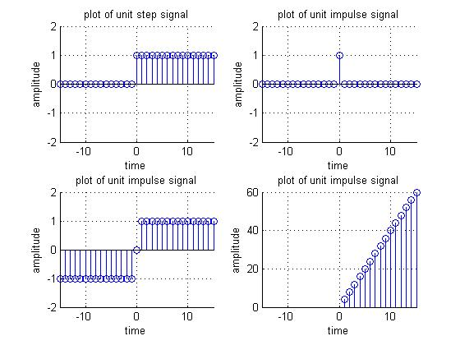

Fig 01 :Output of question 1

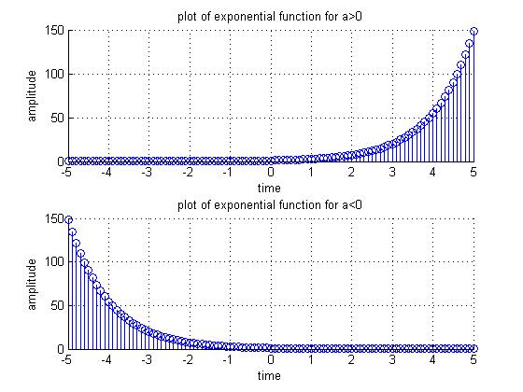

Fig 02 :Output of question 2

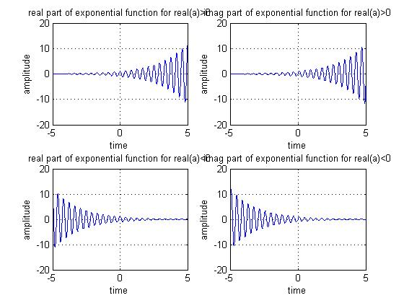

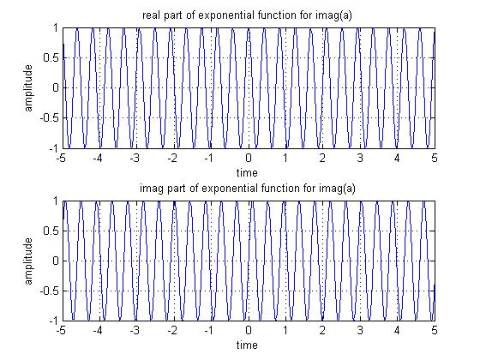

Fig 03: Output of question 3

**Discussion and conclusion:**

Here in this lab we get familiarize and introduced how to plot those different types of basic signals. Those were unit step signal, unit impulse signal, signum signal, ramp signal, real exponential functions and complex exponential functions. We also got introduced with the software called MAT Lab by the help of it we were able to generate those different types of basic signals using different conditions like in real , complex and changing the values of different variables . Hence we generate those basic signals with given scenarios and timelines with the help of mat lab using mat lab code.